**Environmental Monitoring**

Creating an ESP32 IoT project to monitor temperature is a popular and practical application. In this project, we'll use the ESP32 microcontroller, a temperature sensor (like the DHT22 or DS18B20), and an IoT platform like Adafruit IO or ThingSpeak to display and log temperature data. Here's a step-by-step guide:

**Components you'll need:**

ESP32 development board

Temperature sensor (DHT22, DS18B20, etc.)

Breadboard and jumper wires

USB cable for programming

**Software requirements:**

Arduino IDE (with ESP32 support)

Required libraries for your chosen sensor (e.g., Adafruit DHT sensor library or OneWire library for DS18B20)

**Step 1: Set Up Arduino IDE**

Install the Arduino IDE

**Step 2: Connect the Hardware**

Connect your ESP32 to your computer using the USB cable.

Connect the temperature sensor to DHT22

3. the ESP32. Ensure you have the datasheet or pinout for your specific sensor.

For DHT22, connect VCC to 3.3V, GND to GND, and Data to a GPIO pin (e.g., GPIO4).

For DS18B20, connect VCC to 3.3V, GND to GND, and Data to a GPIO pin (e.g., GPIO4).

**Step 3: Write the Code** Here's a basic example of ESP32 code to read temperature data from a DHT22 sensor.

**Code:**

#include "DHTesp.h"

DHTesp dht;

void setup()

{

Serial.begin(115200);

dht.setup(27);

}

void loop()

{

float temperature = dht.getTemperature();

Serial.print("Temperature: ");

Serial.println(temperature);

dely(10000);

} } }

Select your ESP32 board and COM port in the Arduino IDE.

Click the "Upload" button to upload the code to your ESP32.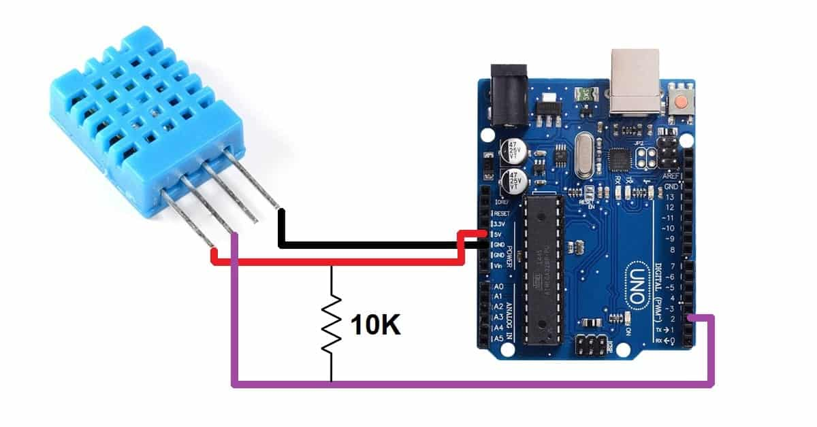

**Step 5: Monitor Temperature Data**

Open the Serial Monitor (Tools > Serial Monitor) to view the temperature readings.

Once you confirm the sensor is working, you can proceed to send data to an IoT platform.

**Step 6: Send Data to IoT Platform**

Sign up for an IoT platform like Adafruit IO or ThingSpeak.

Modify your code to send temperature data to the platform using the appropriate library or API provided by the platform.

Follow the platform's documentation for sending data.

With these steps, you'll have a basic ESP32 IoT project to monitor temperature. You can enhance it by adding features like data logging, remote control, or notifications based on temperature thresholds.

Top of Form

Raspberry-Pi:

To read temperature and humidity data from a DHT11 or DHT22 sensor using raspberry.pi.Here is a python program using the Adafruit DHT library to accomplish this.

**STEPS:**

First, you'll need to install the Adafruit DHT library if you haven't already. Open a terminal on your Raspberry Pi and run the following command:

bash  
CIRCUIT :

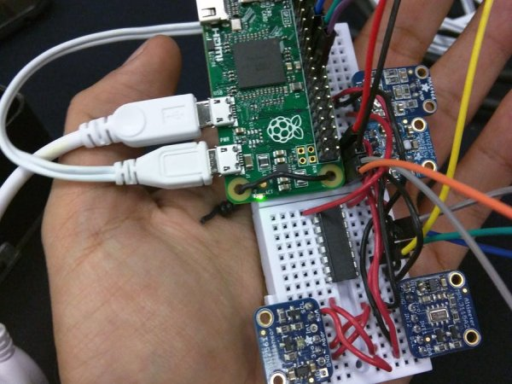

Preparing the Raspberry Pi

Installing the OS

**1.- Download the latest Raspbian.**

[https://www.raspberrypi.org/downloads/raspbian](https://www.raspberrypi.org/downloads/raspbian/)

**2.- Follow the instructions to install the Raspbian in your micro SD card.**

if you are using Linux you can follow these steps to install Raspbian Lite on your micro SD card:

– Check the device name for your micro SD by running :

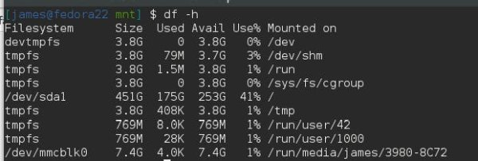

– Unmount your device with the following command

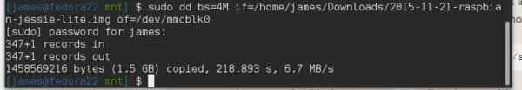

**1.- Expand the Filesystem and Enable I2C**

Login as user: pi password: raspberry

Execute the command sudo raspi-config in the terminal

Select Expand Filesystem and press Enter

Select OK and you will return to the main menu

Select Advanced Options

Select I2C and press Enter

Select Yes and press Enter

Select OK and press Enter

Select Yes and press Enter

Select OK and you will return to the main menu

Select Finish and press Enter

Select Yes and press Enter to reboot the Raspberry pi

**2.Create a Python script (e.g., temperature_humidity.py) and add the following code:**

import Adafruit_DHT

import time

# Set the GPIO pin where your sensor is connected

DHT_SENSOR = Adafruit_DHT.DHT22

DHT_PIN = 4 # Replace with the actual GPIO pin number

try:

while True:

humidity, temperature = Adafruit_DHT.read(DHT_SENSOR, DHT_PIN)

if humidity is not None and temperature is not None:

printf("Temperature: {temperature:.2f}°C, Humidity: {humidity:.2f}%")

else:

printf("Failed to retrieve data from the sensor. Check the wiring.")

time.sleep(2) # You can adjust the sleep duration as needed

except KeyboardInterrupt:

printf("Program terminated by user.")

except Exception as e:

printf(f"Error: {str(e)}")

**3.Save the script and run it:**

python tempThe script will continuously read the temperature and humidity values from the DHT sensor and print them to the terminal. Press **Ctrl+C** to stop the program.

Remember that the DHT11 and DHT22 sensors may have different pinouts and require different parameters, so make sure to adjust the code accordingly. Additionally, double-check your wiring and make sure you have the necessary permissions to access GPIO pins (usually, you need to run the script with superuser privileges or add your user to the group)

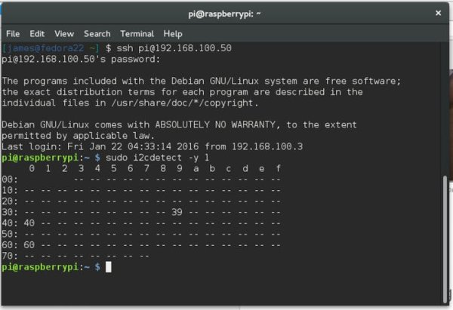

Once you finish the wiring and sensor placement your device should look something like this.

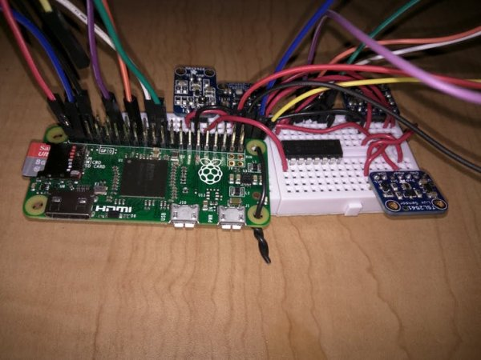

**Define Your Environmental Monitoring Requirements:** Determine what kind of data you want to monitor and how you want to display it in your mobile app. This could include temperature, humidity, air quality, or any other relevant environmental parameters.

**Set Up Hardware Sensors:** Connect environmental sensors (e.g., temperature sensors, humidity sensors, air quality sensors) to microcontrollers like Arduino or Raspberry Pi. These sensors will collect data from the environment.

**Node-RED Configuration:** Use Node-RED to create flows that receive data from your sensors. You can use Node-RED's extensive library of nodes to interface with various sensors and devices. Transform the data and send it to a database or cloud service for storage and analysis.

**Database or Cloud Service:** Store the data collected from the sensors in a database or cloud service. This can be a simple local database, cloud-based databases like Firebase, or IoT platforms like AWS IoT or Azure IoT.

**Build the Node-RED-API Bridge:** Create an API in Node-RED to access the data you've collected. This API will provide a way for the MIT App Inventor to request and retrieve data from Node-RED.

**MIT App Inventor:** Using MIT App Inventor, design and build your mobile app. You can create the app's user interface, define how the data will be displayed, and set up features for data retrieval. Use the Web component in MIT App Inventor to make HTTP requests to the Node-RED API.

**Data Visualization:** Implement data visualization in your app, such as charts, graphs, or simple text displays, to present the environmental data in a user-friendly way.

**Real-time Updates:** Use features in MIT App Inventor and Node-RED to enable real-time updates. For example, you can set up Node-RED to push data to the app whenever a new reading is available.

**Testing and Debugging:** Test your mobile app and Node-RED flows thoroughly to ensure they work as expected. Debug any issues that may arise during testing.

**Deployment:** Once your app and Node-RED flows are working correctly, deploy them to the target environment, such as a mobile device or a tablet. Users can then install and use the app for environmental monitoring.

**Maintenance:** Regularly maintain and update your app and monitoring system to ensure data accuracy and reliability.

Creating a complete Node-RED flow for environmental monitoring is a detailed process, and it depends on the specific sensors and hardware you are using. However, I can provide you with a simple example of a Node-RED flow that simulates environmental data (temperature and humidity) and sends it to a cloud-based database (Firebase) for storage. You can adapt and expand this flow according to your specific sensors and requirements.

**Basic Node-RED flow**:

**Inject Node**: Use an "inject" node to simulate data. You can set it to inject data periodically (e.g., every minute).

**Function Node (Temperature and Humidity Simulation)**: Use a "function" node to generate simulated temperature and humidity data. You can use JavaScript to create random values within the desired range.

**Example function node code:**

msg.payload = {

temperature: Math.floor(Math.random() * 30) + 10,

humidity: Math.floor(Math.random() * 70) + 30,

};

return msg;

**Firebase Output Node**: Configure a Firebase output node to write the data to your Firebase Realtime Database.

In the Firebase Output node, set up the Firebase configuration with your database URL and credentials.

Configure the node to write the data to the appropriate Firebase path (e.g., "/environmental_data").

**Debug Node**: Add a "debug" node to check the data before it is sent to Firebase. This is useful for debugging purposes.

**Dashboard (Optional)**: If you want to visualize the data in Node-RED's dashboard, you can use dashboard nodes (e.g., "ui_chart" or "ui_text") to display the data.

**Use in a Node-RED "function" node to generate a timestamp and send it as part of the payload:**

**var currentDate = new Date();**

**var timestamp = currentDate.getTime();**

**var formattedTimestamp = currentDate.toISOString();**

**var payload = {**

**timestamp: timestamp,**

**formattedTimestamp: formattedTimestamp**

**};**

**msg.payload = payload;**

**return msg;**

**const temperature = Math.floor(Math.random() * 30) + 10;**

**const humidity = Math.floor(Math.random() * 70) + 30;**

**const data = {**

**temperature: temperature,**

**humidity: humidity**

**};**

**const jsonData = JSON.stringify(data);**

**const xhr = new XMLHttpRequest();**

**const url = "https://your-server-endpoint.com/api/environment-data";**

**xhr.open("POST", url, true);**

**xhr.setRequestHeader("Content-Type", "application/json");**

**xhr.onload = function() {**

**if (xhr.status === 200) {**

**console.log("Data sent successfully");**

**} else {**

**console.error("Failed to send data. Status code: " + xhr.status);**

**}**

**};**

**xhr.send(jsonData);**